**Computer Networks Lab Report**

### **Assignment – 2**

**Problem Statement:**  
Design and implement flow control mechanisms of Logical Link Control of Data Link Layer within a simulated network environment.

### **Student Details**

* **Name:** Sumesh Ranjan Majee
* **Roll Number:** 002310501020
* **Year:** 3rd Year B.C.S.E
* **Group:** A1
* **Date:** 12th September 2025

### **Subject:**

Computer Networks

Design

## ****1. Purpose of the Program****

The purpose of this program is to **design and implement flow control mechanisms at the Data Link Layer** in a simulated network environment. Specifically, the program implements and compares three Automatic Repeat reQuest (ARQ) schemes:

* **Stop and Wait**
* **Go-Back-N ARQ**
* **Selective Repeat ARQ**

The program uses a **Sender** and **Receiver** connected via a simulated channel that can introduce **random delays** (causing timeouts and retransmissions). Each data frame includes addressing, sequence numbers, payload, and a Frame Check Sequence (FCS) from Assignment 1 (Checksum/CRC).

This lab demonstrates how different ARQ techniques handle **flow control, acknowledgements, and retransmissions** under delay conditions, and allows measuring their relative efficiency and reliability.

## Structural Diagram of the Program

The program is organized into **8 files**:

* **6 Java files** – Core ARQ protocol implementation
* **1 Python file** – Analytics and performance visualization
* **1 Shell script** – Compilation and execution automation

## File Structure

**1. Sender.java**

* Main entry point for the sender side
* Handles MAC address conversion from hex to binary format
* Creates frames using FrameBuilder and manages connection setup
* Provides menu-driven interface to select ARQ schemes:
  + Stop and Wait
  + Go-Back-N ARQ
  + Selective Repeat ARQ
* Contains shared constants: TIMEOUT_MS (5000ms), TOTAL_FRAMES (150), PROB (95%), window size N (7)

**2. Receiver.java**

* Server-side implementation that listens for incoming connections
* Implements receiver logic for all three ARQ schemes:
  + stop_and_wait() - Simple acknowledgment with ACK loss simulation
  + go_back_arq() - Cumulative ACK with duplicate ACK for out-of-order frames
  + selective_repeat_arq() - Individual frame ACKs with NAK support for missing frames
* Simulates ACK/NAK loss with 95% delivery probability
* Handles frame buffering and ordering for selective repeat

**3. StopAndWait.java**

* Implements Stop-and-Wait ARQ protocol
* Sends one frame at a time and waits for ACK
* Handles timeout and retransmission for lost frames or ACKs
* Measures round-trip time (RTT) for each frame
* Tracks frame transmission times with frameTimes and sendTimeMap

**4. GoBackARQ.java**

* Implements Go-Back-N ARQ protocol with sliding window
* Maintains window of unacknowledged frames (size N=2)
* Uses cumulative acknowledgments
* Retransmits entire window on timeout
* Tracks timing for all frames within the sliding window

**5. SelectiveRepeatARQ.java**

* Implements Selective Repeat ARQ protocol
* Individual acknowledgment for each frame
* Supports NAK (Negative Acknowledgment) for requesting specific lost frames
* Maintains sender-side buffer with sliding window mechanism
* Only retransmits specifically requested frames

**6. FrameBuilder.java**

* Constructs network frames from input file data
* Creates 60-byte frames (480 bits total) with structure:
  + Source MAC address (48 bits)
  + Destination MAC address (48 bits)
  + Length field (16 bits)
  + Payload data (368 bits from input file)
* Reads input file in 46-character chunks
* Calls error detection methods (references Utils.getChecksum() from Assignment 1)

**7. analytics.py**

* Performance analysis and visualization tool
* Reads CSV files generated by each ARQ scheme:
  + csvframe_times_stop_and_wait{prob}.csv
  + csvframe_times_go_back_n{prob}.csv
  + csvframe_times_selective_repeat{prob}.csv
* Generates comparative bar chart histogram showing average acknowledgment times
* Tests multiple transmission success probabilities (80%, 85%, 90%, 95%, 100%)
* Exports performance metrics to performance_metrics.csv
* Auto-scales y-axis based on timeout behavior

**8. compile_and_run_ass2.sh**

* Automates the complete compilation and execution workflow
* **Steps performed:**
  1. **User Input Collection:** Prompts for port, input file path, sender MAC, and receiver MAC (with defaults)
  2. **Java Compilation:** Compiles all Java files in Assignment2 directory
  3. **Receiver Startup:** Launches Receiver as background process on specified port
  4. **Sender Execution:** Runs Sender with user-provided parameters
  5. **Process Management:** Gracefully terminates receiver after completion
  6. **Analytics Generation:** Executes Python script to generate performance visualizations
* **Default Configuration:**
  1. Port: 5000
  2. Input file: Assignments/Assignment2/inputfile.txt
  3. Sender MAC: 98-BA-5F-ED-66-B7
  4. Receiver MAC: AA-BA-5F-ED-66-B7
* **Python Integration:** Uses Anaconda Python path (/c/Users/User/anaconda3/python.exe)
* **Output:** Generates detection_histogram.png and performance_metrics.csv

## Key Features

* **Socket-based communication** between sender and receiver
* **Configurable transmission loss simulation** (PROB parameter)
* **Timeout and retransmission handling** with 5-second timeouts
* **Performance measurement** tracking RTT and total transmission times
* **Comparative analysis** across different ARQ schemes and loss probabilities
* **Automated execution pipeline** with shell script orchestration

## Dependencies

The implementation references utilities from Assignment 1:

* Assignments.Assignment1.Utils.exportToCSV() - CSV export functionality
* Assignments.Assignment1.Utils.getChecksum() - Checksum calculation (from error detection assignment)

This represents a comprehensive **ARQ (Automatic Repeat Request) protocol simulation** focusing on **flow control and reliability mechanisms** with automated testing and performance analysis capabilities.

### 

**Input / Output Specification**

* **Input Format:**
  + A text file containing any txt data

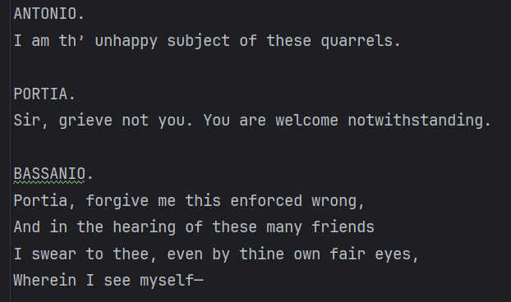

* + Choice ch
  + 1. Stop and Wait
  + 2. Go-Back-N ARQ
  + 3. Selective Repeat ARQ
  + 0. To Exit
* **Output Format:**
  + For each transmitted frame depending on schema:
    - Displays whether **Sender Frame lost or sent successfully** and **Receiver Ack lost or sent successfully** detected an error.
  + Final analytics:
    - Histogram plots
    - performance_metrics.csv file

***Stop and wait***

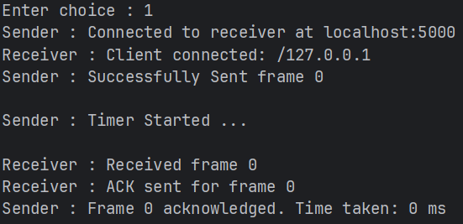

***Go Back ARQ***

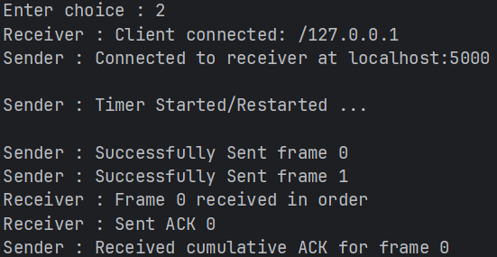

***Selective Repeat ARQ***

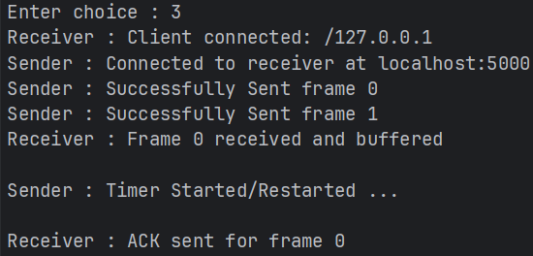

**Implementation**

**Sender Side**

**1. Frame Creation**

1. The **input file** is read entirely and divided into **frames of 64 Bytes (512 bits)**.

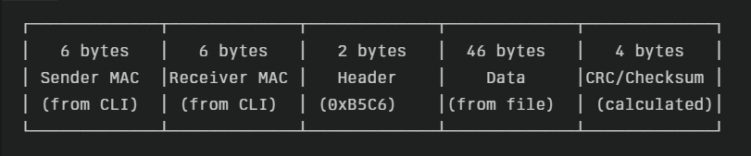

1. The **payload (46 Bytes)** is extracted from the text file.
2. A function createFrames() is used to construct frames:
   * **a. Frame Construction**
     + The 46 Bytes is converted to binary 0 and 1
     + Each frame is built with:
       - Sender MAC address
       - Receiver MAC address
       - 2-byte header
       - Payload (46 Bytes)
     + If the payload is **less than 46 Bytes**, it is padded with **zeros**.
   * **b. Frame List Creation**
     + All frames are stored in a **list**.
   * **c. Error Detection Code Appending**
     + For each frame, **Checksum** values are calculated.
     + These values are appended to the frame, making it a complete **64 Byte frame**.
     + Finally, all frames are stored in a **List<String>** structure.
     + The list is returned to the **Sender**.

## ****3. Frame Transmission****

### ****a. Stop-and-Wait ARQ****

* **How it Works:**
  + The sender transmits **one frame at a time**.
  + After sending, a **timer starts** and the sender **waits for an ACK** from the receiver.
  + **If ACK arrives within timeout:**
    - The sender stops the timer and sends the **next frame**.
    - Timer restarts for the new frame.
  + **If no ACK within timeout:**
    - The timer expires, indicating possible loss or delay.
    - The sender **retransmits the same frame** and restarts the timer.
* **In the Program:**
  + Implemented in StopAndWait.java using a single send/receive loop.
  + A dedicated **Timer** class or method tracks the round-trip time.
  + The sender moves to the next frame only after a valid ACK is received.

### ****b. Go-Back-N ARQ****

* **How it Works:**
  + The sender transmits a **window of N frames** without waiting for individual ACKs.
  + It then waits for a **cumulative ACK** from the receiver.
  + **If cumulative ACK arrives within timeout:**
    - The sender slides the window forward and transmits new frames.
    - Timer restarts from the frame after the last acknowledged one.
  + **If timeout occurs:**
    - The sender retransmits **all frames starting from the last unacknowledged frame**.
* **In the Program:**
  + Implemented in GoBackARQ.java with a **sender window** and a **receiver window of size 1**.
  + Uses a loop to send up to N frames and a timer to monitor the oldest unacknowledged frame.
  + Cumulative acknowledgements shift the window forward.
  + On timeout, frames are resent in order starting at the lost frame.

### ****c. Selective Repeat ARQ****

* **How it Works:**
  + The sender transmits a **window of N frames** like Go-Back-N, but acknowledgements are **individual, not cumulative**.
  + The receiver buffers out-of-order frames and acknowledges them separately.
  + **If ACKs arrive within timeout:**
    - The sender only slides the window forward for acknowledged frames.
  + **If timeout occurs for specific frames:**
    - The sender **retransmits only those unacknowledged frames**.
  + **If NAK is received:**
    - The sender immediately retransmits the specific frame without waiting for a timeout.
* **In the Program:**
  + Implemented in SelectiveRepeatARQ.java with **equal sender and receiver window sizes**.
  + Maintains a buffer for out-of-order frames at the receiver.
  + Uses per-frame timers or a map of timers to track unacknowledged frames individually.
  + Selective retransmission minimizes bandwidth waste and improves performance under delay.

| **Protocol** | **Sending Pattern** | **ACK Handling** | **Timeout Handling** | **Retransmission Strategy** |
| --- | --- | --- | --- | --- |
| **Stop-and-Wait** | One frame at a time | Single ACK | Whole frame timeout | Retransmit same frame |
| **Go-Back-N** | Window of N frames | Cumulative ACK | Timer for oldest frame | Retransmit from last unacknowledged frame onward |
| **Selective Repeat** | Window of N frames | Individual ACK per frame | Per-frame timeout | Retransmit only unacknowledged/NAK’d frames |

## ****Receiver Side Implementation****

The **Receiver** program complements the Sender by accepting incoming frames, checking for errors, and sending acknowledgements (ACK/NAK) back according to the ARQ protocol being used. It is implemented in Receiver.java.

### ****1. Common Receive Process (All ARQ Schemes)****

* The Receiver listens on a socket for incoming frames from the Sender.
* For each received frame:
  + **Extract header fields** (Source MAC, Destination MAC, Sequence Number, etc.).
  + **Extract payload** (46 bytes or more, depending on configuration).
  + **Check for errors** using Checksum/CRC (from Assignment 1).
  + If error-free → Accept the frame and deliver payload.
  + If error detected → Discard frame (or buffer for Selective Repeat if applicable).

### ****2. Stop-and-Wait ARQ (Receiver)****

* **Expected Sequence Number:** The Receiver keeps track of the next expected frame number.
* **On Correct Frame:**
  + If the frame sequence number matches the expected number and passes CRC/Checksum:
    - Deliver the payload to the upper layer.
    - Send an **ACK** back to the Sender for that frame.
    - Increment the expected sequence number.
* **On Error/Unexpected Frame:**
  + Discard the frame (no ACK sent).
  + Sender will timeout and retransmit.

### ****3. Go-Back-N ARQ (Receiver)****

* **Window Size = 1** (Receiver accepts only in-order frames).
* **On Correct Frame:**
  + If the frame sequence number matches the expected number and passes CRC/Checksum:
    - Deliver payload.
    - Send **cumulative ACK** indicating the last correctly received in-order frame.
    - Increment expected sequence number.
* **On Out-of-Order or Corrupted Frame:**
  + Discard the frame.
  + **Repeat the ACK for the last correctly received frame** (cumulative ACK).
  + Sender retransmits from that frame onwards after timeout.

### ****4. Selective Repeat ARQ (Receiver)****

* **Window Size = N** (Receiver accepts multiple frames, including out-of-order).
* Maintains a **buffer** for out-of-order frames.
* **On Correct Frame (within window):**
  + Store the frame in buffer if it is out of order.
  + If it matches the lowest unreceived frame number:
    - Deliver it to the upper layer.
    - Also deliver any consecutively buffered frames.
  + Send an **ACK** specifically for the received frame number.
* **On Corrupted Frame:**
  + Discard the frame.
  + Optionally send a **NAK** immediately to request retransmission (if NAK is enabled).
* This selective acknowledgement mechanism allows the Sender to retransmit **only the missing/errored frames**, reducing bandwidth waste.

| **Protocol** | **Receiver Window** | **Handling of Out-of-Order Frames** | **Acknowledgement Type** | **Error Handling** |
| --- | --- | --- | --- | --- |
| **Stop-and-Wait** | 1 | Discards all unexpected frames | Single ACK per frame | Silent discard → Sender timeout |
| **Go-Back-N** | 1 | Discards out-of-order frames | Cumulative ACK of last in-order frame | Silent discard → Sender retransmits from last ACK |
| **Selective Repeat** | N | Buffers out-of-order frames | Individual ACK per frame + optional NAK | Retransmit only missing frames |

### ****6. Integration with Sender****

* The Receiver continuously runs its Recv() method to accept frames.
* For each valid frame, it calls Check() to verify CRC/Checksum.
* Depending on the ARQ scheme selected, it calls Send() to transmit either ACKs, cumulative ACKs, or NAKs.
* When all frames are processed, it closes the socket connection.

**Test Cases**

Since only **delay (no bit errors)** is implemented, the test cases focus on how each protocol behaves under different delay conditions:

| **Test Case** | **Description** | **What is Checked** | **Expected Outcome** |
| --- | --- | --- | --- |
| **1. No Delay (Ideal Channel)** | Transmit frames with no artificial delay | Baseline throughput and correctness | All frames received and acknowledged with no retransmissions. Stop-and-Wait is slowest but no loss. |
| **2. Small Random Delay (Low probability)** | Introduce small random delays (probability 0.05) | Timeout handling and efficiency | Few or no timeouts. All three schemes deliver successfully; Go-Back-N and Selective Repeat show better utilization than Stop-and-Wait. |
| **3. Medium Delay (probability 0.1)** | Moderate random delays between sender and receiver | Sliding window efficiency, retransmission rate | Stop-and-Wait begins to show larger idle times. Go-Back-N retransmits windows after timeout. Selective Repeat retransmits only delayed frames. |
| **4. High Delay (probability 0.15)** | High random delay simulating a congested channel | Stress test of timeout/retransmission logic | High retransmission rates. Selective Repeat expected to perform best since it only retransmits affected frames. |
| **5. Compare Average Round Trip Time (RTT)** | Measure time between sending a frame and receiving its ACK under different delay settings | Accuracy of timer and timeout calculations | Proper RTT computation, dynamic adjustment of timeout interval. |

## ****3. Results****

* **No Delay:** All three schemes delivered frames successfully with no retransmissions. Stop-and-Wait showed the lowest throughput due to idle waiting time; Go-Back-N and Selective Repeat achieved higher throughput.
* **Low Delay (p=0.05):** Very few timeouts occurred. Go-Back-N and Selective Repeat retained high efficiency.
* **Medium Delay (p=0.1):** Stop-and-Wait experienced noticeable idle times; Go-Back-N retransmitted windows on timeout; Selective Repeat retransmitted only delayed frames, thus saving bandwidth.
* **High Delay (p=0.15):** Stop-and-Wait throughput dropped significantly; Go-Back-N wasted bandwidth due to window retransmissions; Selective Repeat handled delays more gracefully and achieved the highest throughput.
* **RTT Measurement:** The timer and timeout mechanism correctly computed the round-trip times, and timeout thresholds adjusted accordingly.

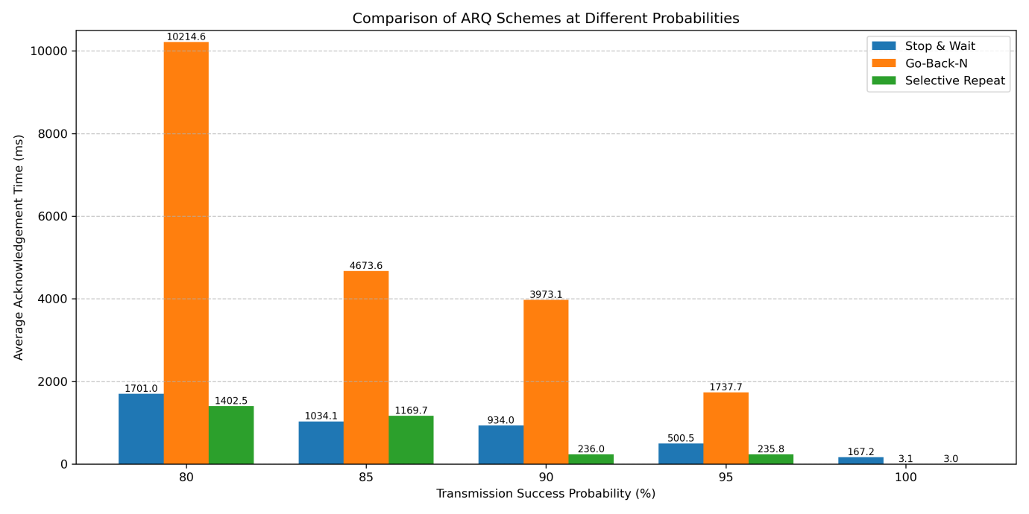

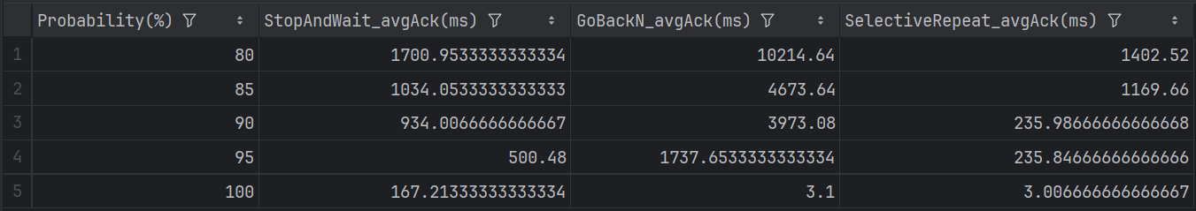

## ****4. Analysis****

* **Stop-and-Wait ARQ:** Simple to implement but inefficient under delay because only one frame is outstanding at a time; sender idle during RTT.
* **Go-Back-N ARQ:** Better utilization since multiple frames are in flight. However, if one frame is delayed or lost, the entire window must be retransmitted.
* **Selective Repeat ARQ:** Most efficient under delay because only the affected frames are retransmitted. Requires more complex receiver buffering and independent acknowledgements but reduces wasted bandwidth.
* **Overall Trend:** As delay increases, protocols with **larger window sizes and selective retransmission (Selective Repeat)** outperform simpler schemes (Stop-and-Wait).

**5. Comments**

This lab provided practical insight into **flow control and error recovery mechanisms**. It demonstrated how different ARQ schemes behave under delayed acknowledgements and how timeouts drive retransmissions.

* **Learning Outcome:**
  + Gained hands-on experience with timers, sequence numbers, acknowledgements, and window-based transmission.
  + Learned how delays affect throughput and reliability.
* **Difficulty:**
  + Moderate. Understanding timers and implementing sliding windows required careful logic but was manageable.
* **Improvements Suggested:**
  + Add **bit error simulation** from Assignment 1 for a more realistic test.
  + Provide a **graphical visualization of window sliding** to make debugging easier.
  + Include a **configurable timeout calculation** (adaptive algorithms).

## ****6. Conclusion****

In this assignment, three flow control mechanisms—Stop-and-Wait, Go-Back-N ARQ, and Selective Repeat ARQ—were implemented and compared under different delay conditions.

Results showed that while **Stop-and-Wait** is simplest, it becomes inefficient as delays grow. **Go-Back-N ARQ** improves throughput but wastes bandwidth during retransmissions of entire windows. **Selective Repeat ARQ** delivers the best performance under delay since it retransmits only the frames actually delayed or lost.

This lab highlights the importance of **sliding windows and selective retransmission** in modern networking protocols, demonstrating how more complex flow control mechanisms improve network efficiency and reliability in real-world conditions.